.

**Department of Computer Science and Business Systems | Rajalakshmi Engineering College**

123



06 - Strings in Python

For example:

.

**Department of Computer Science and Business Systems | Rajalakshmi Engineering College**

124



Input Result rec@123

3

3

1

**Ex. No. : 6.1 Date: 16.04.2024**

.

**Department of Computer Science and Business Systems | Rajalakshmi Engineering College**

125



**Register No.: 231401038 Name: INIYA S**

# Count Chars

Write a python program to count all letters, digits, and special symbols respectively from a given string

**CODE:**

**string = input( )**

**alphabets = digits = special = 0**

**for i in range(len(string)): if(string[i].isalpha()):**

**alphabets = alphabets + 1 elif(string[i].isdigit()):**

**digits = digits + 1 else:**

**special = special + 1 print(alphabets) print(digits) print(special)**

Sample Input 1 a2b4c6

.

**Department of Computer Science and Business Systems | Rajalakshmi Engineering College**

126



Sample Output 1 aabbbbcccccc

**Ex. No. : 6.2 Date: 16.04.2024**

.

**Department of Computer Science and Business Systems | Rajalakshmi Engineering College**

127



**Register No.: 231401038 Name: INIYA S**

# Decompress the String

Assume that the given string has enough memory. Don't use any extra space(IN- PLACE)

**CODE:**

**S = input().strip() result = "" current_char = "" count = 0**

**for char in S:**

**if char.isdigit():**

**count = count * 10 + int(char) else:**

**result += current_char * count current_char = char**

**count = 0**

**result += current_char * count print(result)**

Input Format:

.

**Department of Computer Science and Business Systems | Rajalakshmi Engineering College**

128



The first line contains S1. The second line contains S2. The third line contains N.

Output Format:

The first line contains the N characters present in S1 which are also present in S2. Boundary Conditions:

2 <= N <= 10

2 <= Length of S1, S2 <= 1000 Example Input/Output 1:

Input:

abcbde cdefghbb 3

Output:

bcd Note:

b occurs twice in common but must be printed only once.

**Ex. No. : 6.3 Date: 16.04.2024**

.

**Department of Computer Science and Business Systems | Rajalakshmi Engineering College**

129



**Register No.: 231401038 Name: INIYA S**

# First N Common Chars

Two string values S1, S2 are passed as the input. The program must print first N characters present in S1 which are also present in S2.

**CODE:**

**s1 = input().strip() s2 = input().strip()**

**n = int(input().strip()) common_chars = [] for char in s1:**

**if char in s2 and char not in common_chars: common_chars.append(char)**

**if len(common_chars) == n: break**

**print(''.join(common_chars))**

Sample Input 1 experience

.

**Department of Computer Science and Business Systems | Rajalakshmi Engineering College**

130



enc

Sample Output 1 xpri

**Ex. No. : 6.4 Date: 16.04.2024**

.

**Department of Computer Science and Business Systems | Rajalakshmi Engineering College**

131



**Register No.: 231401038 Name: INIYA S**

# Remove Characters

Given two Strings s1 and s2, remove all the characters from s1 which is present in s2.

Constraints

1<= string length <= 200

**CODE:**

**s1 =input() s2 =input()**

**result = ''.join([char for char in s1 if char not in s2])**

**print(result)**

For example:

.



**Department of Computer Science and Business Systems | Rajalakshmi Engineering College** 132



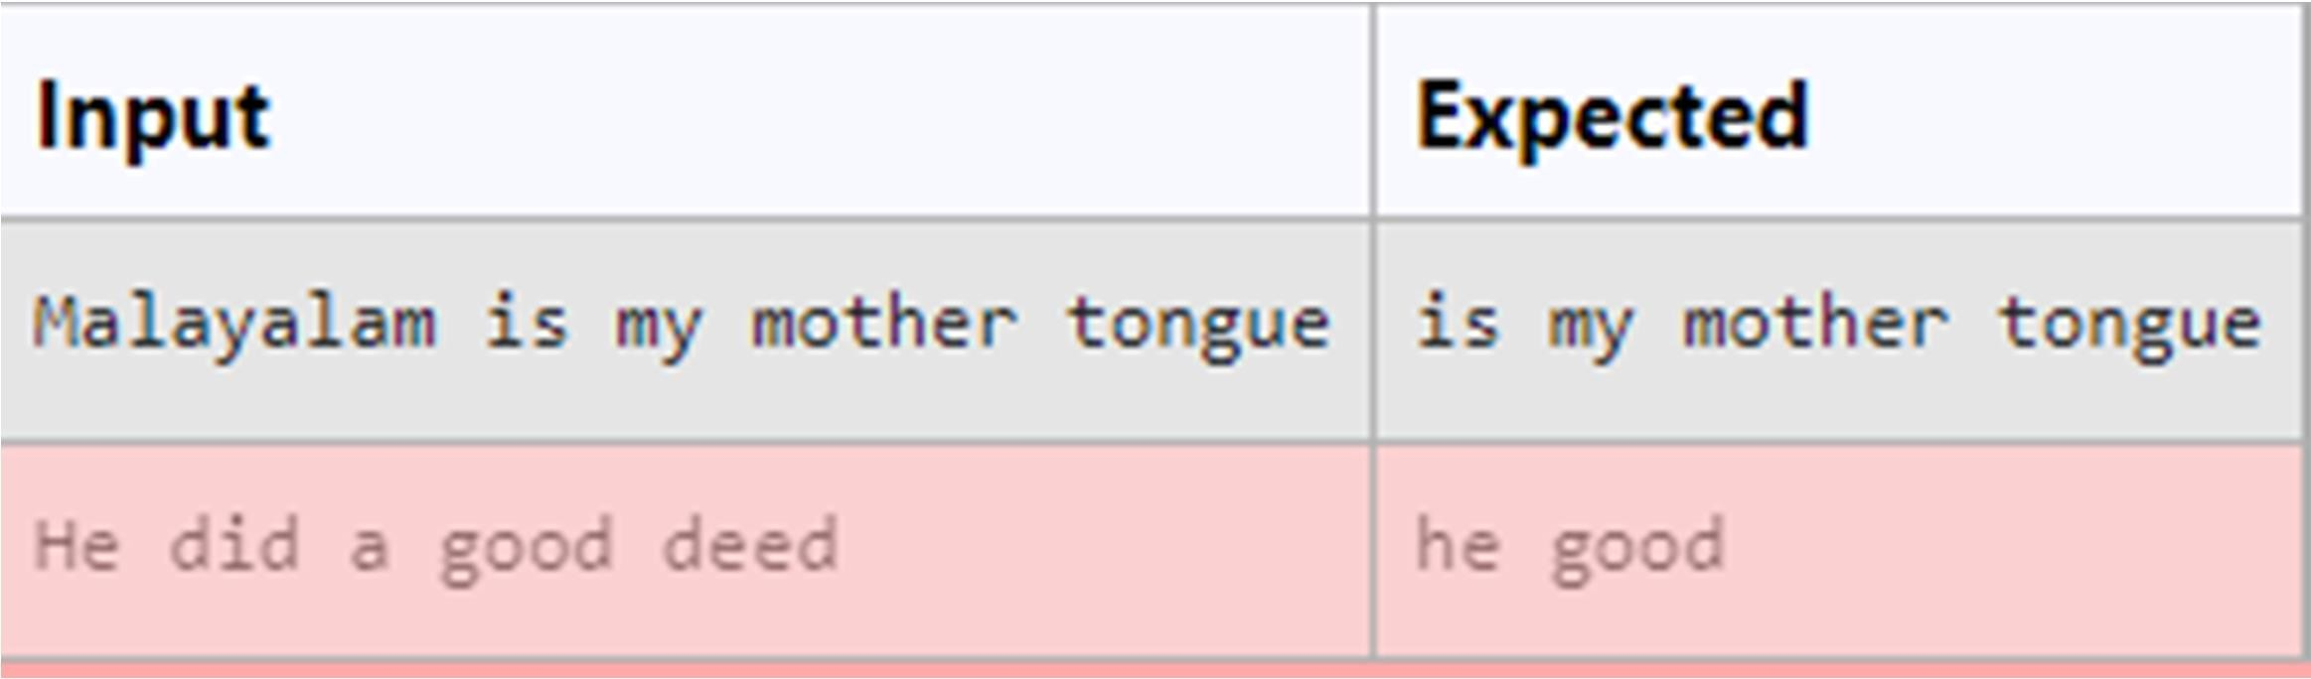

**Ex. No. : 6.5 Date: 16.04.2024**

.

**Department of Computer Science and Business Systems | Rajalakshmi Engineering College**

133



**Register No.: 231401038 Name: INIYA S**

# Remove Palindrome Words

String should contain only the words are not palindrome.

Sample Input 1

Malayalam is my mother tongue

Sample Output 1

is my mother tongue

**CODE:**

**x=input() z=x.lower() y=z.split(" ") for i in y:**

**if i!=i[::-1]:**

**print(i, end=" ")**

For example:

.

**Department of Computer Science and Business Systems | Rajalakshmi Engineering College**

134



Input Result

Wipro Technologies Bangalore TECHNOLOGIES

Hello World WORLD

Hello LESS

**Ex. No. : 6.6 Date: 16.04.2024**

.

**Department of Computer Science and Business Systems | Rajalakshmi Engineering College**

135



**Register No.: 231401038 Name: INIYA S**

# Return Second World in Uppercase

Write a program that takes as input a string (sentence), and returns its second word in uppercase.

For example:

If input is “Wipro Technologies Bangalore” the function should return “TECHNOLOGIES”

If input is “Hello World” the function should return “WORLD” If input is “Hello” the program should return “LESS”

NOTE 1: If input is a sentence with less than 2 words, the program should return the word “LESS”.

NOTE 2: The result should have no leading or trailing spaces.

**CODE:**

**s= input() s=s.split() if len(s)>1:**

**print(s[1].upper()) else:**

**print('LESS')**

Input:

.

**Department of Computer Science and Business Systems | Rajalakshmi Engineering College**

136



A&B Output:

B&A

Explanation: As we ignore '&' and

As we ignore '&' and then reverse, so answer is "B&A".

For example:

Input Result A&x#

x&A#

**Ex. No. : 6.7 Date: 16.04.2024**

**Department of Computer Science and Business Systems | Rajalakshmi Engineering College**

137



**Register No.: 231401038 Name: INIYA S**

# Revers String

Reverse a string without affecting special characters. Given a string S, containing special characters and all the alphabets, reverse the string without affecting the positions of the special characters.

**CODE:**

**def is_alphabet(char): return char.isalpha()**

**def reverse_string_with_special_chars(S):**

**S = list(S)**

**left = 0**

**right = len(S) - 1**

**while left < right:**

**if not is_alphabet(S[left]): left += 1**

**elif not is_alphabet(S[right]): right -= 1**

.

**else:**

.

**Department of Computer Science and Business Systems | Rajalakshmi Engineering College**

138



**S[left], S[right] = S[right], S[left] left += 1**

**right -= 1**

**return ''.join(S)**

**S = input().strip()**

**print(reverse_string_with_special_chars(S))**

For example:

.

**Department of Computer Science and Business Systems | Rajalakshmi Engineering College**

139



Input Result Yn

PYnative True

**Ex. No. : 6.8 Date: 16.04.2024**

.

**Department of Computer Science and Business Systems | Rajalakshmi Engineering College**

140



**Register No.: 231401038 Name: INIYA S**

# String characters balance Test

Write a program to check if two strings are balanced. For example, strings s1 and s2 are balanced if all the characters in the s1 are present in s2. The character’s position doesn’t matter. If balanced display as "true" ,otherwise "false".

**CODE:**

**def check_balanced_strings(s1, s2): return set(s1).issubset(set(s2))**

**s1 = input() s2 = input()**

**result = check_balanced_strings(s1, s2) print(result)**

**Input:**

.

**Department of Computer Science and Business Systems | Rajalakshmi Engineering College**

141



first second first third second

then your program should display:

**Output:** first second third

**Ex. No. : 6.9 Date: 16.04.2024**

.

**Department of Computer Science and Business Systems | Rajalakshmi Engineering College**

142



**Register No.: 231401038 Name: INIYA S**

# Unique Names

In this exercise, you will create a program that reads words from the user until the user enters a blank line. After the user enters a blank line your program should display each word entered by the user exactly once. The words should be displayed in the same order that they were first entered. For example, if the user enters:

**CODE:**

**unique_words = [] while True:**

**word = input().strip() if word == "":**

**break**

**if word not in unique_words: unique_words.append(word)**

**for word in unique_words: print(word)**

Example Input/Output 1:

.

**Department of Computer Science and Business Systems | Rajalakshmi Engineering College**

143



**Input**: [vijayakumar.r@rajalakshmi.edu.in](mailto:vijayakumar.r@rajalakshmi.edu.in) **Output**:

edu.in rajalakshmi vijayakumar.r

**Ex. No. : 6.10 Date: 16.04.2024**

**Department of Computer Science and Business Systems | Rajalakshmi Engineering College**

144



**Register No.: 231401038 Name: INIYA S**

# Username Domain Extension

Given a string S which is of the format [USERNAME@DOMAIN.EXTENSION,](mailto:USERNAME@DOMAIN.EXTENSION) the program must print the EXTENSION, DOMAIN, USERNAME in the reverse order.

**Input Format**:

The first line contains S.

**Output Format**:

The first line contains EXTENSION. The second line contains DOMAIN. The third line contains USERNAME.

**Boundary Condition:**

1 <= Length of S <= 100

CODE:

email = input().strip() at_index = email.index('@') dot_index = email.index('.') username = email[:at_index]

domain = email[at_index+1:dot_index] extension = email[dot_index+1:] print(extension)

print(domain) print(username)

.

.

**Department of Computer Science and Business Systems | Rajalakshmi Engineering College**

145

